Regarde les images. Trouve la bonne phrase.
A | B | C | D
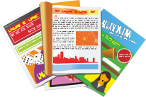
E | F | G | H
 |  | 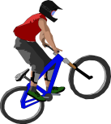 | 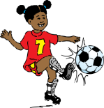
I | J | K | L
 |  |  | 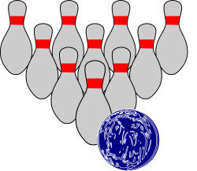

1. aller au cinéma | 7. écouter de la musique
2. faire du sport | 8. lire des BD
3. faire les magasins | 9. faire du vélo
4. aller au bowling | 10. jouer à des jeux électroniques
5. aller en ville | 11. danser
6. manger au fast-food | 12. regarder la télé

A | B | C | D | E | F | G | H | I | J | K | L
 |  | 12

Teaching notes

This PowerPoint resource will provide structured speaking practice of free time activities, with a team game to encourage careful listening. The worksheet on p.1 is provided as an optional starter activity designed to get students engaged as soon as they arrive and to ensure that they all revise the key vocabulary.
Worksheet answers
A | B | C | D | E | F | G | H | I | J | K | L
8 | 5 | 12 | 1 | 3 | 10 | 9 | 2 | 7 | 6 | 11 | 4

PowerPoint
Slide 1
This will remind students of the key vocabulary and can also be used to check the worksheet answers if this has been completed. Go through the images in order, clicking to display the answers.

Slide 2
This presents the same set of images without the support of the words. Begin by saying one of the phrases at random and asking students to give you the corresponding letter. Then reverse the process and say one of the letters to elicit the matching phrase from the class.

Next, remind them that they can put ‘J’aime’ in front of these expressions. Still using the letters ask, for example, ‘G, qu’est-ce que tu aimes faire?’ to elicit the reply ‘J’aime faire du vélo’. Two successive clicks will reveal a model question and answer at the bottom of the slide. Students could also practise this in pairs once the model is established.

Slide 3
This is a guessing game. Use the list below of what each person likes doing but don’t share this with the class.

Stéphanie aime aller au bowling.
Grégory aime aller en ville.
Monique aime faire du sport.
Ludovic aime aller au cinéma.
Céline aime jouer à des jeux électroniques.
Marc aime écouter de la musique.
Clara aime faire du vélo.
Patrice aime danser.
Sandrine aime lire des BD.

Divide the class into two teams. By taking turns to make guesses (e.g. ‘Marc aime danser?’) they must find out what each person likes. An extra click will bring up this question as a model.

Every correct guess earns a point and the first team to reach five points wins. To avoid wasting guesses, they must listen carefully to other people’s questions.

When a correct guess has been made, this should be indicated by crossing out the person and activity on the whiteboard. This will remind pupils not to mention this person or activity again.

It can take some time for the first correct guess to be made – particularly if there is no strategy to the guessing and if pupils are not listening carefully to each other – but the game will gradually speed up as more correct guesses are made.

There are more activities than there are people so some activities will not be used at all. This ensures that the final guess is not inevitable in the event of a draw.

Students could then be asked to write a sentence for each of the matches that have been made to see how many they can remember.

